

**Spring 2021**

**CSE103L-Circuit and System-I lab**

**Submitted by: Maaz habib**

**Registration No.: 20PWCSE1952**

Class Section: **C**

 “On my honour, as student of University of Engineering and Technology, I have neither given nor received unauthorized assistance on this academic work.”

**Submitted to:**

**Engr. Faiz Ullah**

Department of Computer Systems Engineering

University of Engineering and Technology, Peshawar

**EXPERIMENT NO: 9 and 10**

**Verification of nortion’s and Thevenin’s theorem**

**Objectives of the lab:**

**To verify Thevenin’s and Norton’s theorem on simulation tool PSPICE.**

**What is nortion’s theorem?**

**Definition:**

**Norton’s theorem** is an analytical method used to change a complex circuit into a simple equivalent circuit consisting of a single resistance in parallel with a current source. **Norton** on the other hand reduces his circuit down to a single resistance in parallel with a constant current source.

**Circuit diagram:**

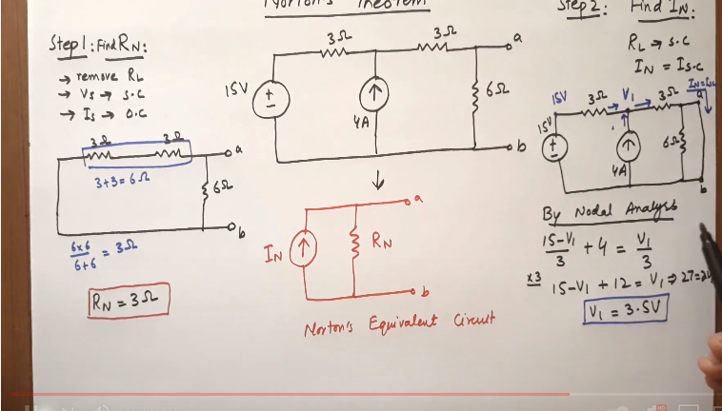

**Thevenin’s theorem:**

Thevenin’s **theorem** states that, "For any linear electrical network containing only voltage sources, current sources and resistances can be replaced at terminals A-B by an equivalent combination of a voltage source Vth in a series connection with a.

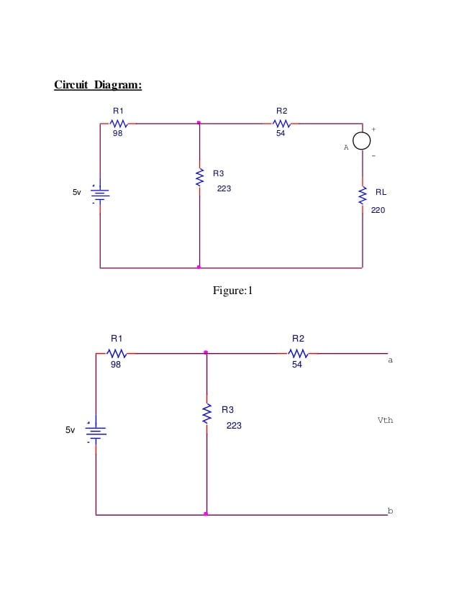

**What is pspice simulator**?

Introduction

Pspice stands for ((Simulation Program for Integrated Circuits Emphasis).

PSPICE is a computer-aided simulation program that enables you to design a circuit and then simulate the design on a computer. As this is one of its main purposes, it is used extensively by electronic design engineers for building a circuit and then testing out how that circuit will simulate. A general-purpose analogue circuit simulator that is used to verify circuit designs and to predict the circuit behaviour.

**Steps for simulations:**

1. Keep all the resistance close to their maximum respective values.
2. Close the switch S1 to "aa" and S2 to "cc" positions. ...
3. Remove the load by opening the switch S2 and read the open circuit voltage (or Thevenin equivalent voltage) Vth.

**Procedure:**

1) Open schematic program of Pspice.

2) Click on the “Get New Part” button on the toolbar

3) Type ‘r’ in the search bar and place the eight resistors on the white sheet

4) Type ‘vdc’ in the search bar and place two of them on the white sheet

5) Type ‘gnd-earth’ and place it on the white sheet

**Observation and calculations:**

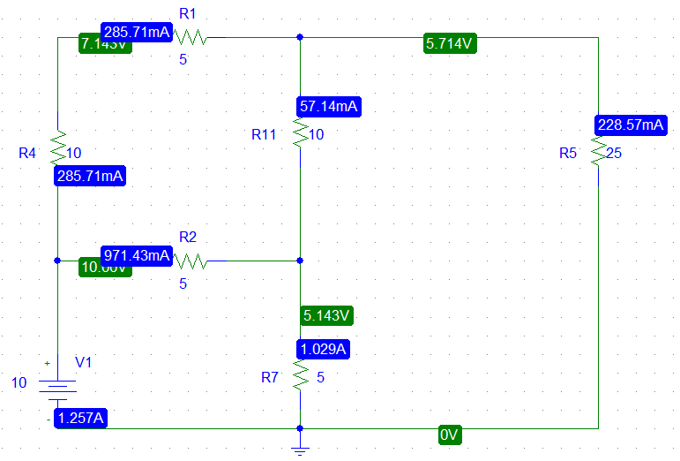

Now we will follow the following steps to find Vth, Isc and Rth.

* Remove one of the resistances
* Find Vth.
* Short the circuit by adding ammeter from where resistance removed.
* Find Isc.
* Using ohm’s law to find the resistance Rth.
* Remove resistor R7, simulate the circuit and note down the voltage across the open circuit.

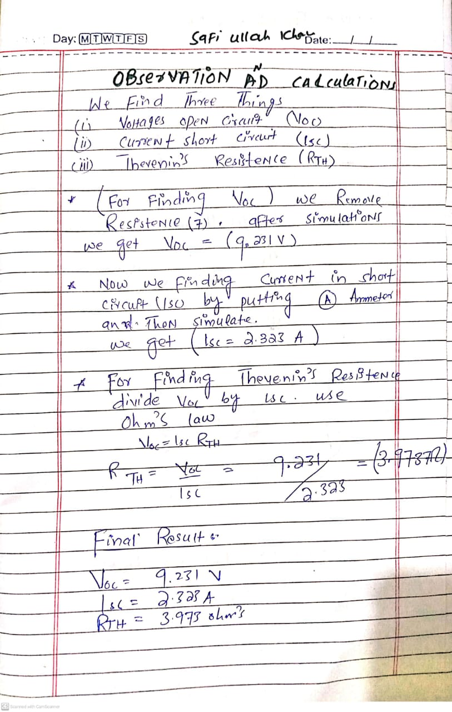

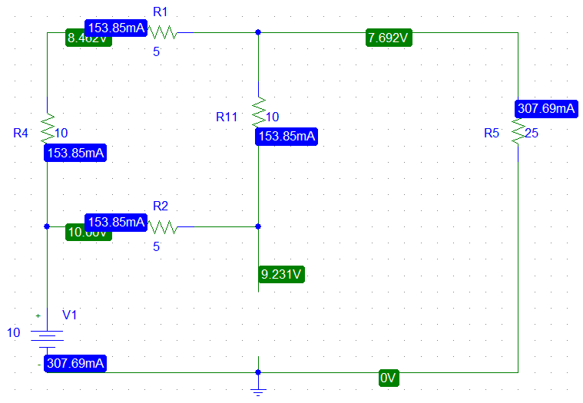

V TH = 9.231V

Now put ammeter to the two free ends of Resistor R7 (short the circuit) and find the current.

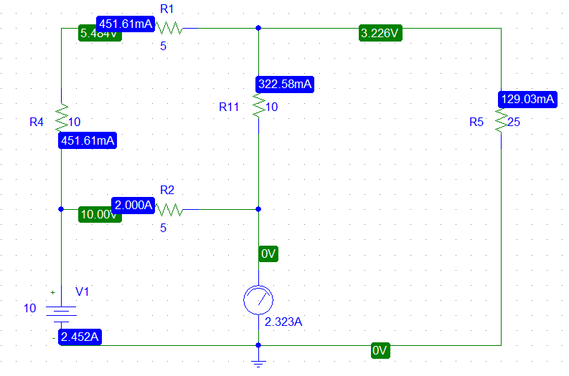

I sc = 2.323A --> (current at short circuit)

**R TH = 9.231/2.323=3.9737Ω**

Thevenin’s to nortion transformation

Or nortion to Thevenin.

**(P.T.0)**

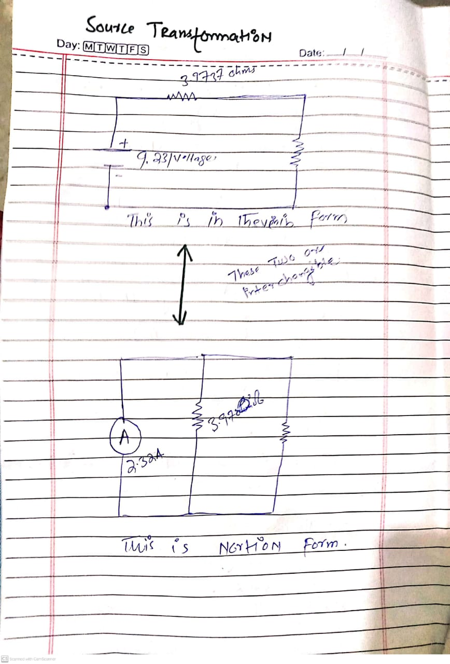

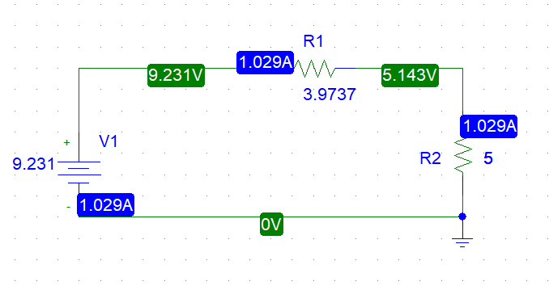

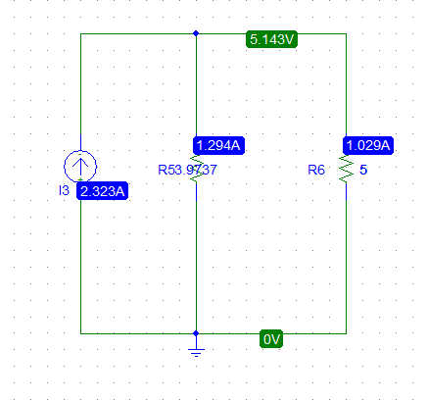

**Conclusion:**

Thevenin’s Theorem states that it is possible to simplify any linear circuit, no matter how complex, to an equivalent circuit with just a single voltage source and series resistance connected to a load. Throughout this experiment, the resistances are simplified into only one that is RTH. The value of RTH obtained from calculation is the same as the value obtained from the measurement, so the Thevenin’s Theorem is verified.

**THE END**